Can't find the book

you're looking for

in our collection?

fILL allows you to borrow items from other Manitoba public libraries.

fILL searches the collections of all 59 Manitoba public libraries to find just the item you are looking for.

If another library has the item and is able to lend it, you will usually hear back within a few days, with the item arriving in about a week.

Here's how you can use fILL to satisfy all your reading needs!

You will need to create an account.

1. From the Welcome page, click **Sign Up!**

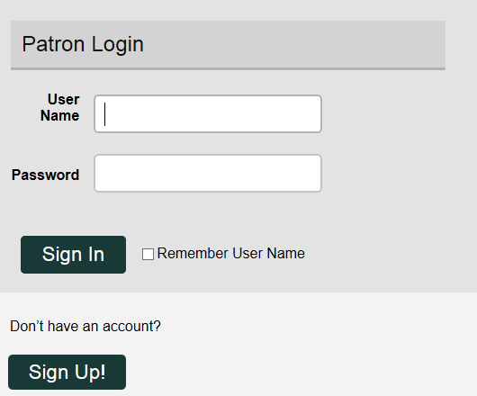

1. Click on the area of the province that you live in.
2. Click on the community where you are a member of the local library.
3. Fill in the requested information

* your name
* library card number
* email address

1. Choose a user name and password.
2. Click **Submit**.

The information you submit to fILL is used to facilitate the lending of items between Manitoba libraries and you. No personally identifying details of transactions are stored in fILL after the library material has been returned. Non-identifying data is retained for statistical purposes.

Searching is Easy...  
Just Click Go.

Searching is Easy...  
Just Click Go.

Once you have set up an account return click **Login to fILL**.

You can search from every page on the fILL website.

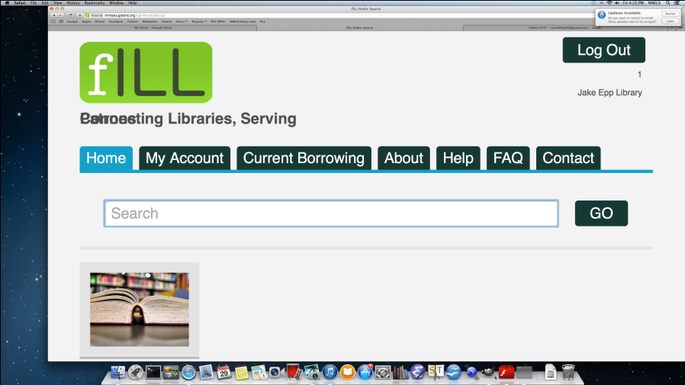

Enter what you are looking for in the search bar, then click **Go**.

When you see an item you'd like to borrow, click on the title then click **Request**.

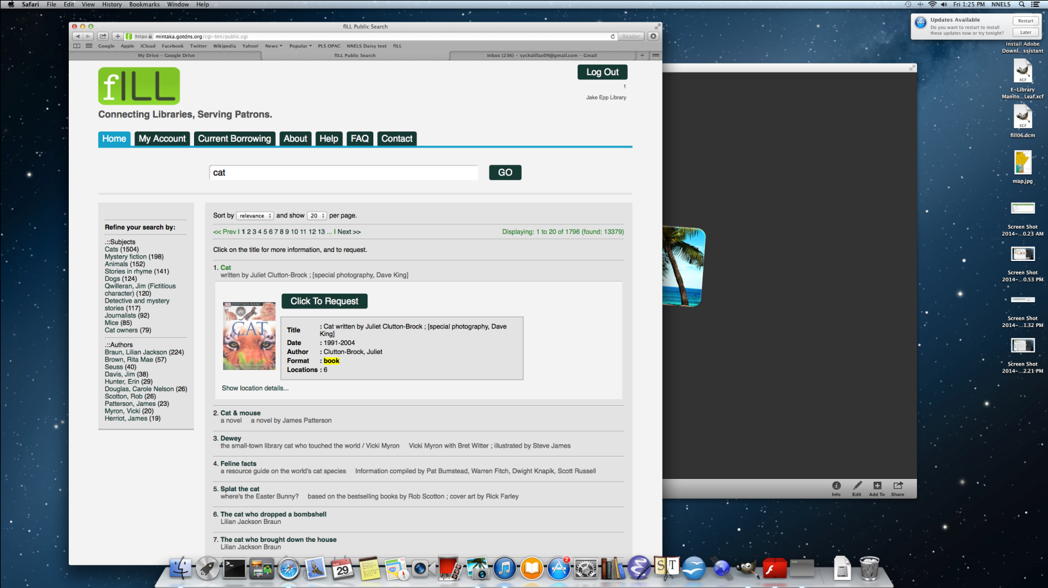

The search page will then say **Your Request has been Placed.**

You have the ability to cancel the request if you made it accidentally.

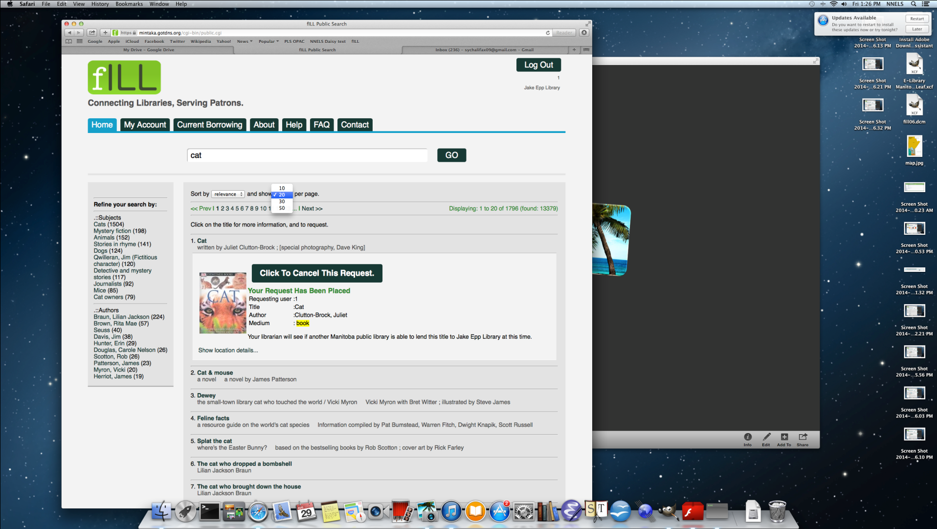

Please contact your local library if you have any questions.

Our contact information is shown in the Contact menu.

Simple Powerful Results.

Refining Your Search.

The search results page enables you to quickly refine your search by subject or author.

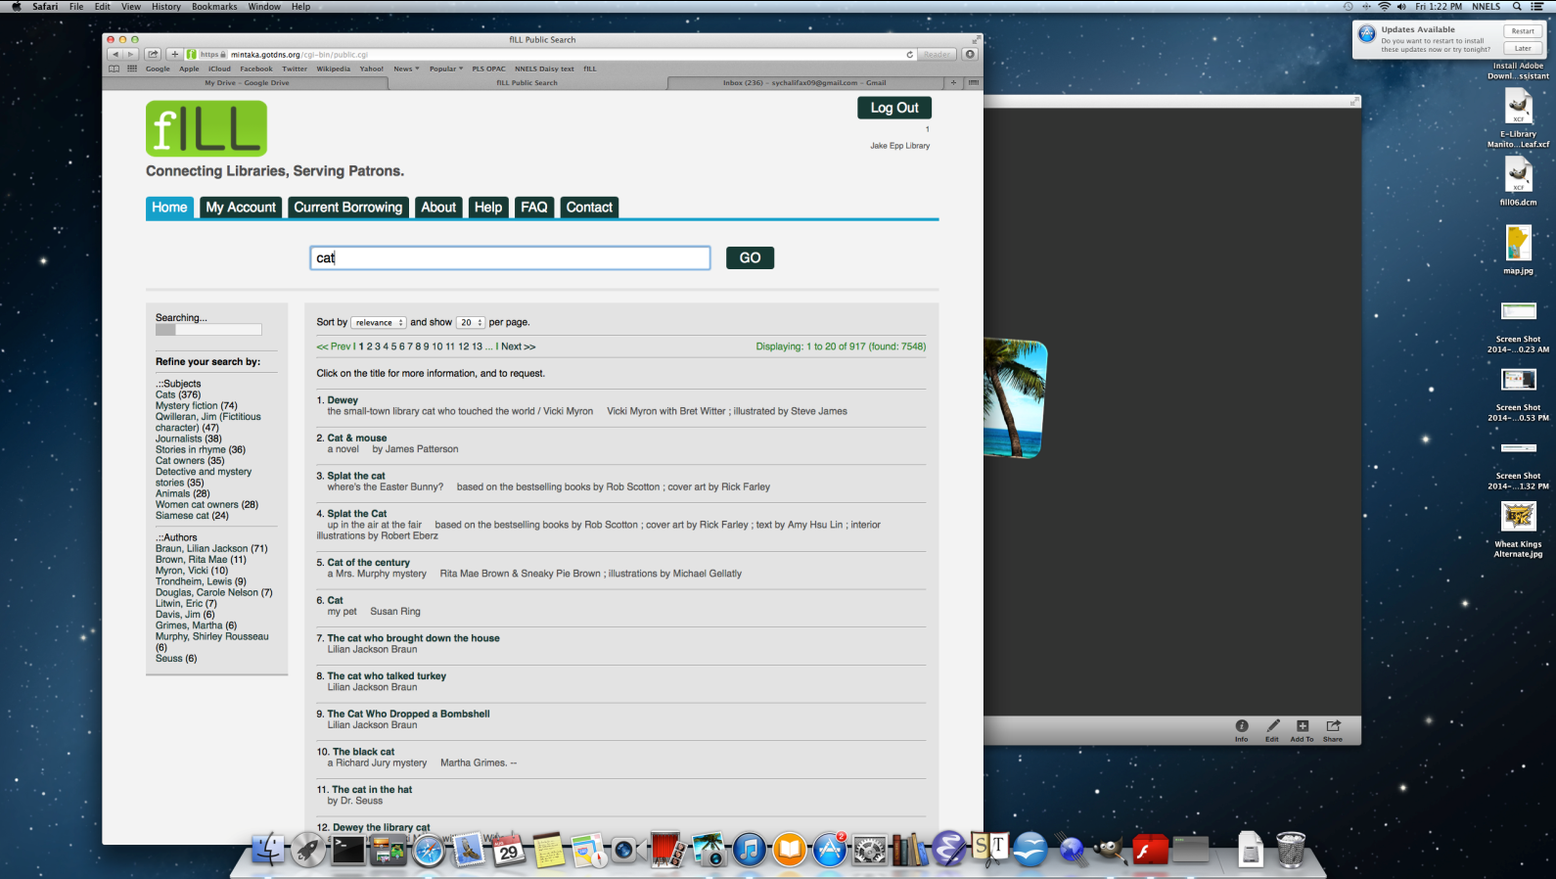

Click on any of the subject or author search terms in the left-hand column to refine your search.

fILL will then automatically search using your new search terms.

You can keep refining your search, until you find exactly what you're looking for.

Simple, Powerful Results.

Sorting.

fILL will automatically sort your results by relevance.

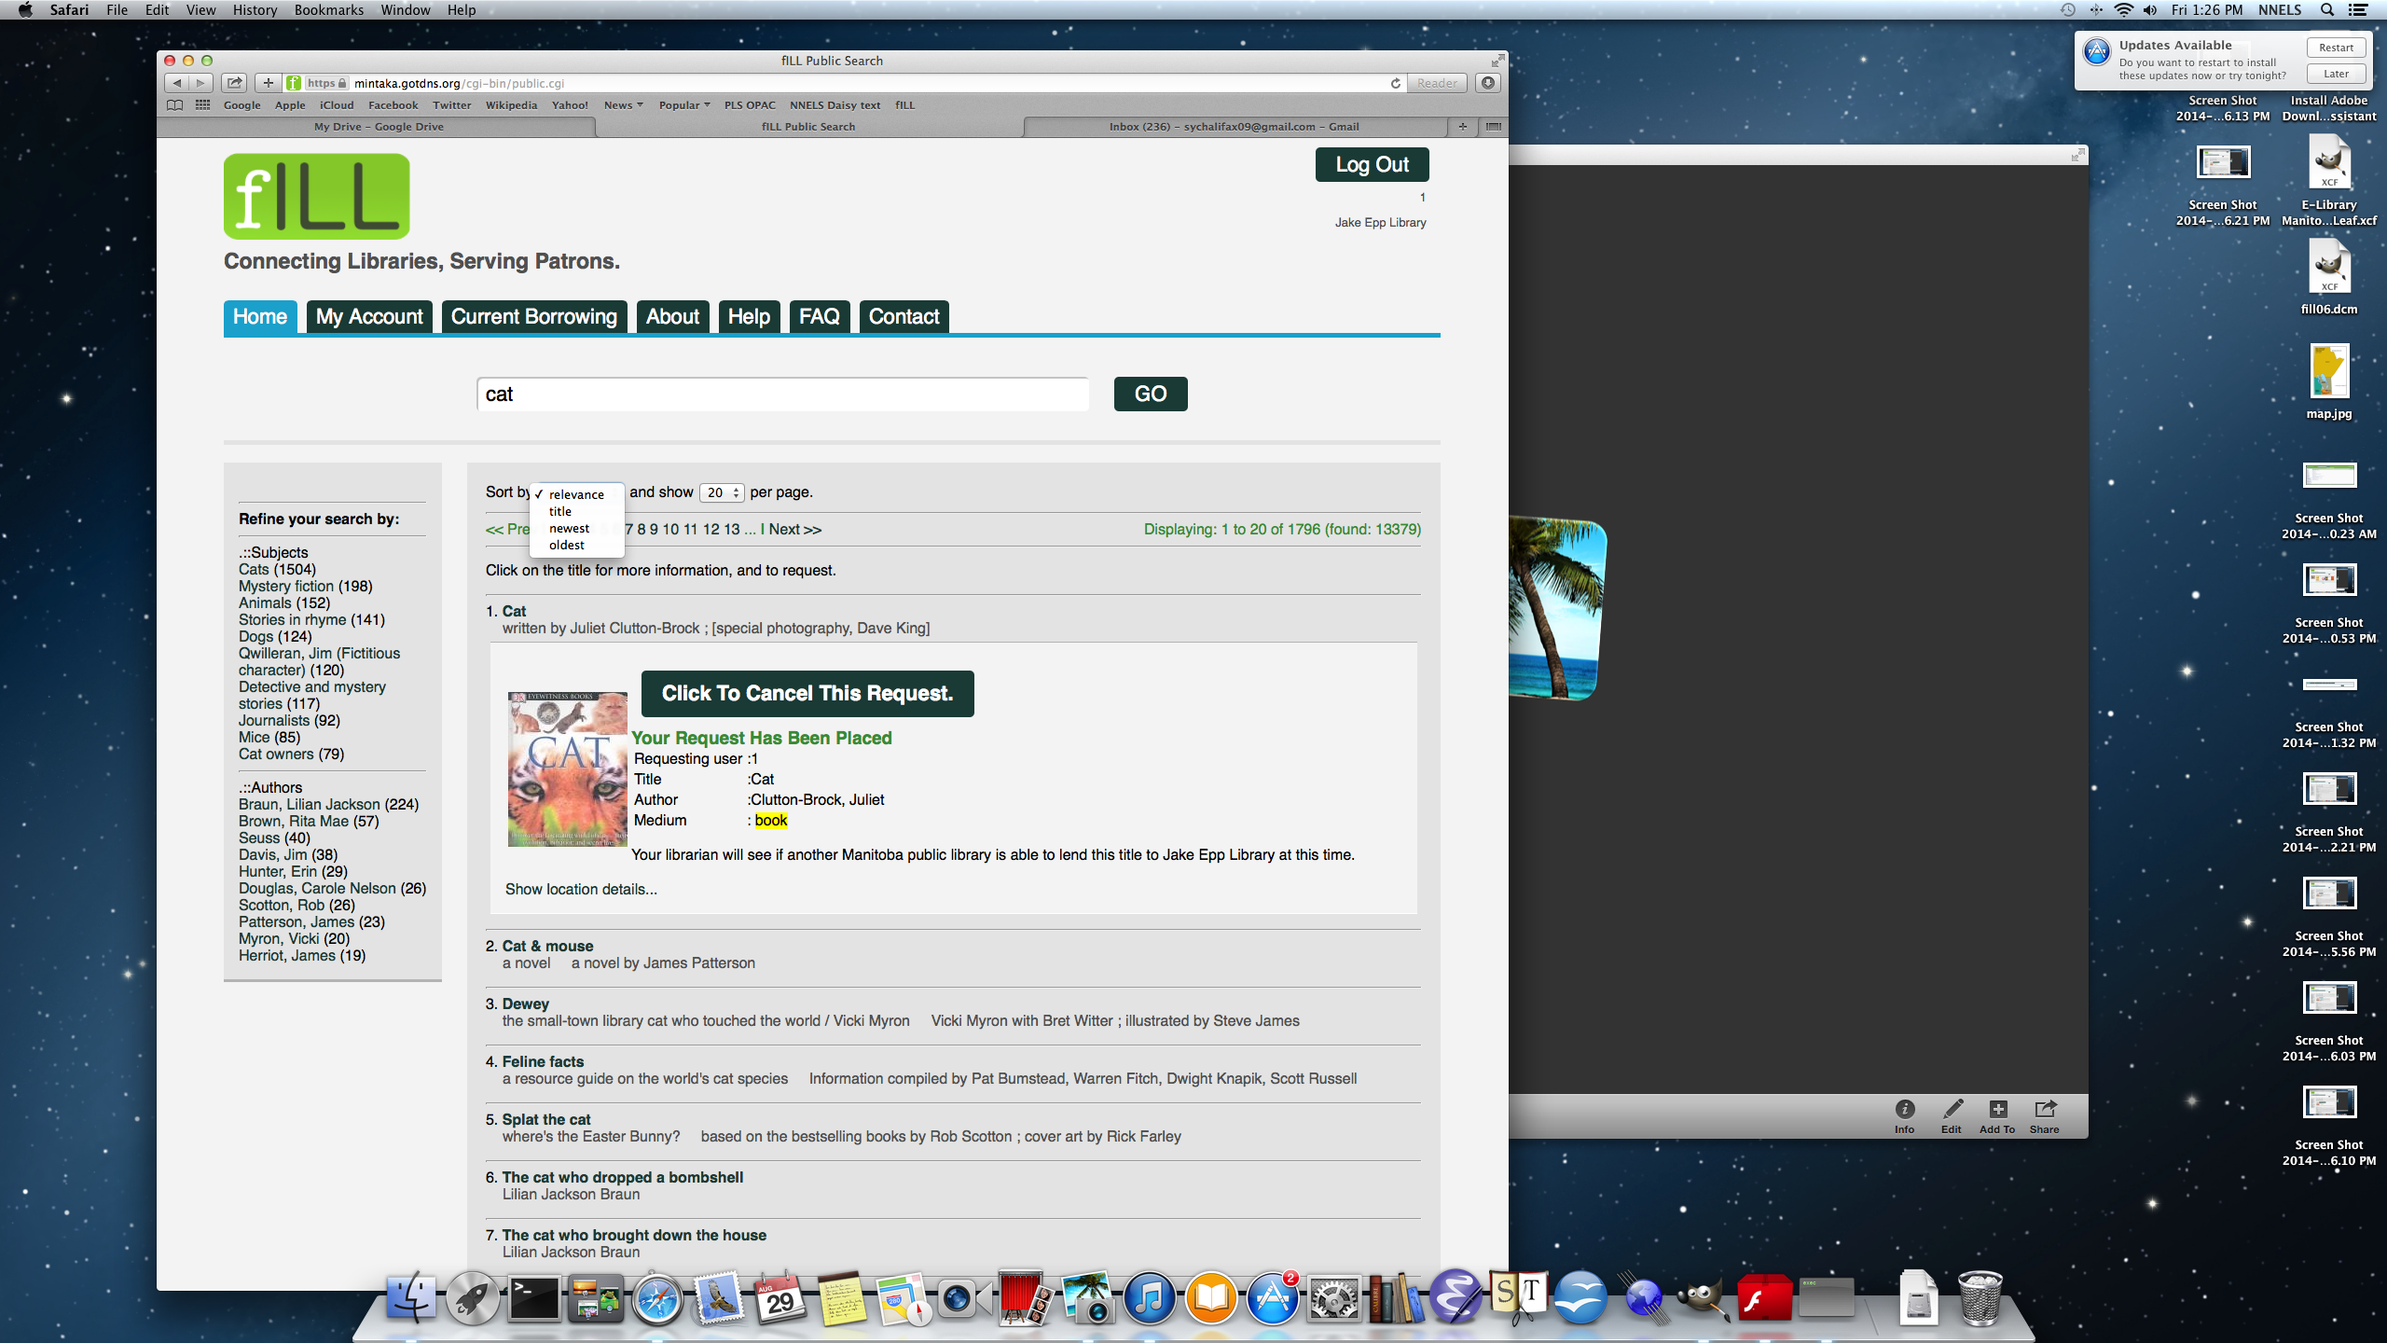

This places the items that most closely match your search terms at the top of the list.

You can also choose to sort your results by title or publishing date by clicking the sort button.

Please contact your local public library if you have any questions.

<https://fill.sitka.bclibraries.ca/>



**Connecting Libraries, Serving Patrons**

**fILL opens up the richness and diversity contained in all the libraries across Manitoba.**

Proudly Supported By

